Evaluation of CY2020 Medicare Home Health Services: Data Updates
Analysis of Preliminary 2020 Medicare Claims to Assess the Early Impact of PDGM Implementation and COVID-19 Pandemic on Home Health Agencies

Submitted to:
Partnership for Quality Home Healthcare (PQHH)

Submitted by:

Al Dobson, Ph.D.
Alex Hartzman, M.P.A., M.P.H.
Sandra Agik, Sc.M.
Sung Kim
Joan DaVanzo, Ph.D., M.S.W.

Thursday, April 15, 2021

Introduction
Implementation of the Patient Driven Groupings Model (PDGM) in the Home Health Prospective Payment System (HH PPS) appears to have occurred at below-budget-neutral payment levels through November, 2020. Though the COVID-19 public health emergency (PHE) has played a significant role in affecting HH case volume and case severity, PDGM itself has had a negative impact on payments with an extraordinarily high LUPA rate as a feature of the system. Other changes in case-mix, referral sources and case volume have occurred, but it is not clear the extent the PHE has played a role in this. Regardless of the root cause of underpayments, the HH PPS base rate was implemented with prospective payment reductions, and observed underpayments would be alleviated by a return to a budget neutral base rate in Calendar Year (CY) 2022.
Dobson DaVanzo & Associates (Dobson | DaVanzo) was commissioned by Partnership for Quality Home Healthcare (PQHH) to analyze 2020 Medicare home health claims data reflecting the initial implementation of the Patient-Driven Groupings Model (PDGM). This report includes analysis of early 2020 claims data (data is mostly complete through November, 2020). We combine this with public data on the timing of state PHE lockdowns as well as state-level COVID-19 test data. This report for the PQHH follows on a series of reports and public comments on the CY2021 Home Health Prospective Payment System (HH PPS) rule. The CY2021 HH PPS Final Rule (FR) did not make adjustments to bring the base rate to a budget neutral level, however CMS may still do so for CY2022.
Effective January 1, 2020, the PDGM overhauled the HH PPS episode and case-mix group definitions, payment weights and base rate. PDGM is a revision of the Home Health Resource Group (HHRG) case-mix group definitions initially proposed in the CY2018 HH PPS administrative rulemaking cycle that was refined and finalized in the CY2019 and CY2020 HH PPS rulemaking cycles. The CY2021 HH PPS rule made limited changes to PDGM. Complicating the preliminary evaluation of PDGM implementation is the ongoing novel coronavirus PHE.
Comparison of preliminary 2020 Medicare claims to projections used in rate setting indicates that home health case volume, total payments, and average payments have declined in 2020, and that LUPA case rates have increased. While it is difficult to precisely parse what effects are due to the PDGM implementation itself and what are due to the ongoing COVID-19 PHE, the outcome so far is that it appears that the CY2020 HH PPS is not budget neutral to prior years. Using available data from January-November 2020 we estimate the system payment rate to be approximately 3.7% below budget neutral payment levels; budget neutrality is discussed in terms of payment rate which is not affected by case volume changes. Agency adjustments made in the remainder of the year and additional claims run-out appear unlikely to make up for the payment rate shortfall, in part due to prospective reductions to the base payment rate for assumed provider behavioral changes enacted by CMS.
When implementing PDGM in the CY2020 Final Rule (FR), CMS prospectively reduced the HH PPS base rate from the budget neutral calculated level by 4.36%. This prospective base rate reduction is inherently a significant contributor to the observed payment shortfall. The level of rate reduction was justified by CMS through analytic assumptions on how providers might change their behavior once PDGM was implemented. In the CY2020 FR, CMS described three underlying assumptions to determine the behavioral adjustment:
- For one-third of LUPAs that are one to two visits away from the LUPA threshold, HHAs will provide one to two extra visits to receive a full 30-day payment.
- HHAs will change documentation and coding practices and put the highest paying diagnosis code as the principal diagnosis code (payment optimized clinical coding). This allows a 30-day period of care to be placed into a higher-paying clinical group.
- By taking into account additional ICD-10-CM diagnosis codes listed on the HHA claim (that exceed the six allowed on the OASIS), more 30-day periods of care will receive a comorbidity adjustment than otherwise would have received if CMS had only used the OASIS diagnosis codes for payment.
Using preliminary 2020 Medicare claims, we find that the behavioral assumptions for PDGM implementation have not held true. Furthermore, these overly aggressive assumptions have implications for home health market stability and subsequent beneficiary access to home health services. We find evidence that neither the LUPA assumption nor the payment optimization of clinical coding assumption have occurred through November 2020. Analyses of preliminarily available data suggest that the COVID-19 PHE may have led to an apparent increase in case-mix severity for the high comorbidity and high functional need groups; utilization decreased overall and LUPA rates increased, but less so among cases with high comorbidity and functional need scores, suggesting patients with the most severe needs were more likely than others to receive full episodes of care.
We commend CMS for making extensive case data available and showing transparency to enable robust and productive commentary by the public. In the CY2020 FR CMS OASIS-LDS PDGM rate-setting and impact files, CMS provided payment estimates which included case-level estimated behavioral responses, as well as data appropriate for reproducing PDGM payments without behavioral responses.

Summary of Findings
We find that the CY2020 HH PPS so far appears to have been implemented at a below budget neutral level. Further, anticipated behavioral changes, case shortfalls and volume reductions deviate from the trends CMS predicted in its initial projections.
- Budget Neutrality: PDGM does not appear to be budget neutral compared to prior years, measured either by average or total aggregate payments.
  - Over the first eleven months of PDGM implementation, observed average case payments were approximately 3.7% lower than projected (average case payment of $1,740 January-November 2020 compared to projected $1,806 from January-November of the FY2020 FR file).
  - Estimated total aggregate payments are about 4.4% lower than projected ($14.8B observed compared to over $15.5B expected for the period).
  - We are confident that findings are robust with over 8.5M home health episodes during the period. We anticipate further changes as providers continue to adapt to PDGM and navigate the unfolding COVID-19 PHE, however, preliminary data provides evidence that corrective action may be warranted to appropriately pay home health providers in CY2022.

- Case Volume Changes: We find a 0.7% reduction in home health episode volume from PDGM and the COVID-19 PHE January-November 2020 compared to the rate-setting file:
  - Case volume initially declined sharply from projections, particularly in the first half of 2020 due to primarily to the unfolding PHE. Subsequently, case volume has rebounded. September-November especially saw changes in prior seasonality patterns of HH cases potentially addressing pent-up demand, which made up for much of the earlier case shortfall.
    - The early 2020 decline in home health utilization can be largely attributed to the COVID-19 PHE as states enacted restrictions to control the spread of the virus. These policy actions mandated lockdowns that halted elective procedures, delayed other procedures, and did not designate therapists as essential workers during the initial onset of the pandemic.
  - We expected an 8.3% seasonal decline in home health cases from October to November and measured a 6.7% decrease instead; it is unclear if the relative increase in November cases is partially due to pent-up demand or if it is a factor of the 60-to-30 day episode conversion that was not anticipated in modeling the impact file.
  - Early in 2020, PDGM case utilization decreased due to the shift from 60-day episodes to 30-day cases and the timing of visits within an episode of care.
    - Projections used in rate-setting also have inherently reduced volume due to data cleaning procedures which removed paid cases; the comparison to historical projections do not fully capture the complete decline in case volume and potentially leads to an underestimate of the shortfall.
    - Some portion of home health visits was shifted to telehealth during this time, however, this shift is not captured in the claims data, per CMS pandemic flexibilities guidance. HHAs can report some costs of providing telehealth on the HHA cost report, but incompletely. Lack of data on telehealth services has implications for future HH PPS rate-setting and rebasing.
  - COVID-19 represents an increasing portion of home health cases – as much as 9% of November home health cases had a COVID-19 diagnosis in the prior 30 days (i.e., possibly still infectious at time of HH service) and 42% have reported possible COVID-19 exposure.
    - A greater portion of home health staff may be at risk of infection than is commonly understood from home health claims.

- Behavioral Assumptions: In HH PPS rulemaking, CMS assumed that agencies would automatically and instantaneously change their coding and visit allocation behavior to maximize reimbursement under the revised payment system. Our results show that home health agencies thus far have not followed this behavioral assumption described by CMS in the CY2020 HH PPS FR to justify the prospective base rate reduction of 4.36%.
  - LUPA rates in 2020 so far are much higher than anticipated, which has contributed to a lower than expected per-case payment rate as well as lower than expected total aggregate case payments. Despite the evolution of the PHE, LUPA rates remain much higher than projected.
    - The PDGM LUPA rate is higher than projected and remains so across 2020 through November. Overall, we find a 15.2% LUPA rate under PDGM. While some portion of this is pandemic-related, the national aggregate LUPA rate is well below its all-time high of 18.2% in March, but still nearly three times higher than CMS projections. While the pandemic dramatically impacted home health activities, we observed a spike in LUPA rates prior to the onset of pandemic responses in March which has not abated despite recouperating utilization. This suggests that agencies are continuing to struggle with the new PDGM LUPA threshold requirements, as they had before the PHE began.
  - Case-mix groups continue to reflect historical trends of primary diagnoses rather than payment-optimized groupings. While CMS assumed that some portion of cases would have their claims submitted such that the highest paying clinical group diagnostic code reported anywhere on the claim would be chosen for the primary diagnosis code, our results show that this has, by and large, not happened. Clinical case-mix groups observed are much more like historical trends from the rate-setting file without the behavioral adjustment.
  - Comorbidity and functional group scores remain higher than anticipated which may be some part behavioral adjustment but also a relative increase in case-mix severity from historical trend. CMS assumed that some cases would have additional comorbidities reported that were also reported elsewhere in that beneficiary’s home health claims or assessment data. While preliminary 2020 claims data show that providers have an increased rate of high comorbidity and functional need cases, total volume of high comorbidity and functional need patients remained relatively consistent to projections from historical trends. Providers are increasingly supplying care to patients of higher complexity, despite or perhaps because of the overall reduction in volume accompanying the COVID-19 PHE, changing referral patterns, and increasing substitution of HH for skilled nursing facility care.

- Case-Mix Severity: Overall aggregate case-mix weights during the period were 1.05 and did not meet the level anticipated in behavioral adjusted projections of 1.07.
  - Case-mix severity in general was higher than historical trends for PDGM (1.00). We further explored issues around case volume decline, LUPA rates, and PDGM case mix group categories and case-mix weights. This provided additional evidence suggesting that increases in case-mix severity are due more to volume changes (where higher need cases are more likely to receive visits) and referral patterns (mix of early/late and community/institutional origin patients) rather than coding changes.

- Sequences of Care: Average PDGM sequence length through November is 2.4 30-day episodes. Sequences are shorter than historical, predominantly due to: a) PDGM was implemented in January, leaving little time for very long sequences, b) changing PHE care patterns featuring different referral sources, case-mixes and shorter duration of care, and c) strong PDGM incentives to start new cases.

- Disentangling PDGM implementation from the COVID-19 PHE: The context of the ongoing PHE must be accounted for in analyes to determine the effect of PDGM implementation itself. We find mixed impacts of the PHE, which had its most obvious effects during the initial shock of American outbreaks and state shutdowns in March and April of 2020. Subsequently, providers began to find a new normal – one that was mostly reflective of historical home health case-mix patterns, but reflects new discharge and upstream referral patterns that still have not recouped elective care or ED care; home health seems now to more often substitute for SNF.
  - We found that case counts and case payments were impacted by the PHE, but the persistently high LUPA rate likely is largely a feature of PDGM.

- Policy Implications: Findings have implications for rate-setting in CY2022.
  - The lack of observed provider behavioral responses so far suggests CMS behavioral assumptions may not come to pass; some part of the occurrence of increased case-mix severity may be a response to the COVID-19 PHE. CMS is explicitly authorized under the Bipartisan Budget Act of 2018 to adjust the CY2021 HH PPS base rate temporarily or permanently to achieve budget neutrality.
  - Home health referral patterns have changed as has the likelihood of home health substituting for SNF care. 2020 likely holds many lessons for substitution across PAC settings, which should be examined further and considered in future bundling programs and unified system activities.
  - The COVID-19 PHE response activities among states, CMS, and providers all serve to make data from this time less reliable and representative than the typical data used for rate-setting, rebasing, and payment reform.
    - This has implications for everything from future rebasing of the HH PPS to the IMPACT Act timeline.

Detailed Findings
The Bipartisan Budget Act of 2018 mandated CMS to develop a new payment model for the Medicare home health program with a number of requirements, namely that: 1) HH PPS cases are shortened from 60 days to 30 days, 2) cases are no longer paid based on volume of therapy services, and 3) changes are implemented in a budget neutral manner. We examined the actual changes in coding under PDGM compared to CMS projections using data from preliminary 2020 claims files and the CY 2020 CMS OASIS-LDS PDGM rate-setting file. Further, we applied public data on the PHE to conduct state-level analyses to disentangle the effects of PDGM from COVID-19.
- Preliminary 2020 claims were available to Dobson | DaVanzo under CMS Research Identifiable File (RIF) Data Use Agreement (DUA) 54757. Data included in this report go through November 2020, the most recent available month with sufficient claims run out.
- Historical projections of PDGM using 2018 data including both a regrouping of HH PPS cases to PDGM as well as the behavioral assumptions are available in the CY2020 OASIS-LDS file, Data Use Agreement 53367. This dataset was issued as a companion to the CY2020 Final Rule.

Budget Neutrality
We find that PDGM does not appear to be budget neutral at its currently implemented base payment levels. This indicates that higher base payments may be required to achieve budget neutrality. Over the first eleven months of implementation, average case payments fell short such that they are 3.7% below statutorily mandated budget neutral payment levels. In Exhibit 1, we show the rate-setting file outputs at the current base rate with CMS behavioral adjustments (Full BA) and without behavioral adjustments (No BA) compared to observed rates from preliminary 2020 RIF claims. Here, Full BA represents projected impact file payments made at 2020 HH PPS rates (set 4.36% below budget neutralityand with assumed behavioral changes). No BA estimates the values those case payments would have been without assumed behavioral adjustments (set 4.36% below budget neutrality).
Average case payments were higher than anticipated in January due to the transition to PDGM (more higher paying “early admission timing” cases because “late admission timing” cases could not occur, increasing average payment) and declined in subsequent months. Per-case payment rates declined subsequently (starting in May) and had yet to recover to budget neutral levels as of November.
Exhibit 1: Actual CY2020 Claims Average Case Payments vs. Projected Case Payments with and without Behavioral Adjustments
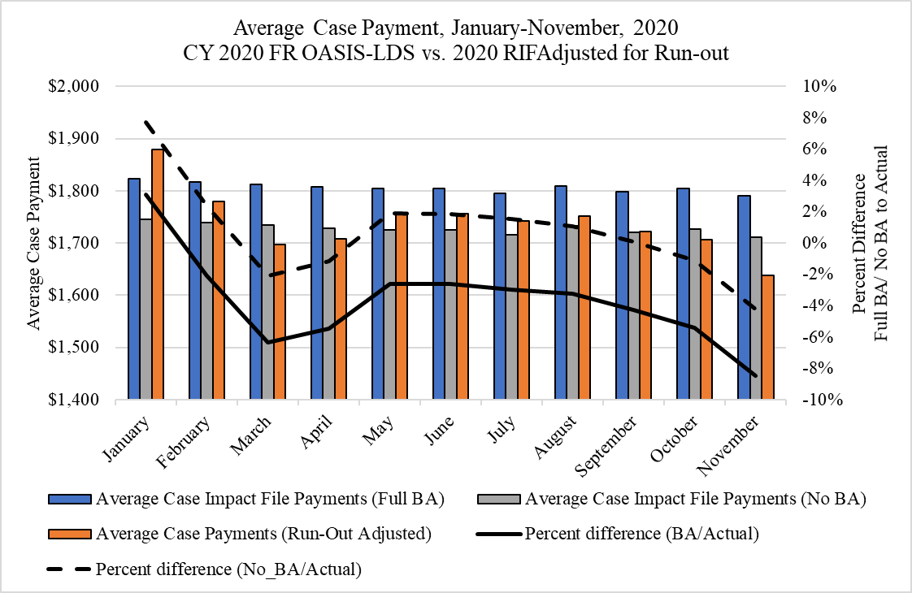
Source: Dobson | DaVanzo Analysis of HH Claims in DUAs LDS 53367 and RIF 54757
Average payments in early 2020 had major declines during the initial PHE and resultant state lockdowns. Though payment levels appeared to recover during the summer, they have once again declined in October and November, perhaps coinciding with the second major wave of outbreaks, but also intersecting with traditional home health and other health system seasonality patterns, and pent-up demand.
Adjustments are made to observed 2020 payments and case counts to account for PDGM transition effects and claims run-out. Transition effects are the 60-day cases in the historic payment system that were completed in 2020 (we make an adjustment to impute these into PDGM cases). We developed claims run-out factors by making repeated measures of payments and cases during fixed time periods as data matured and new data became available. This allowed us to determine claims run-out adjustment factors.
Total HH PPS payments have declined for this period as well (see Exhibit 2). For the January-November period, we found that overall case payments declined by nearly 4.4% relative to the impact file – an estimated total of $14.8B compared to an expected $15.5B. Note that impact file total payments are somewhat lower than actual payments during the period due to extensive case-level data cleaning. Here, estimated 2020 total revenue has been adjusted for PDGM transition effects and claims run-out.
However, we still find substantial overall home health revenue decreases from projections, particularly in March through May, where the most likely contributors are reduced volume and increased LUPAs as a result of the COVID-19 PHE (Exhibit 2).
Exhibit 2: Actual Total CY2020 Medicare HH Case Payments Compared to Projected Total Payments (with and without Behavioral Assumptions)
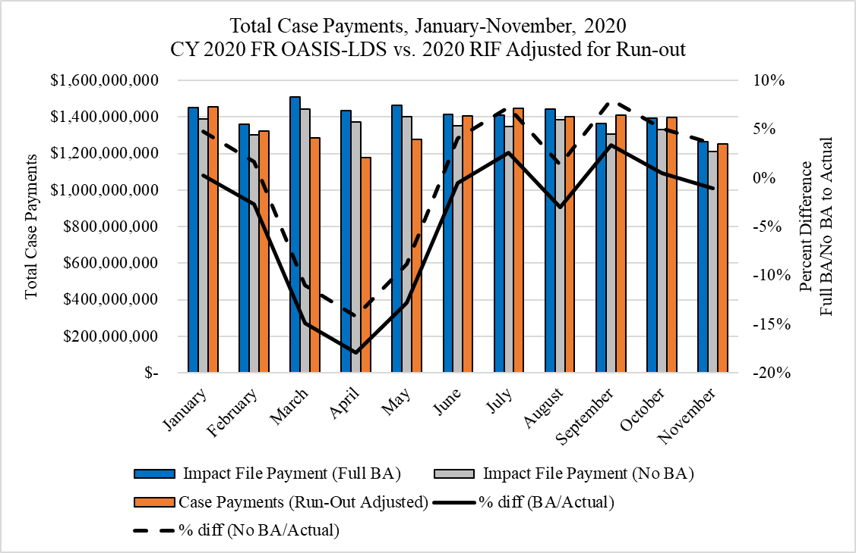
Source: Dobson | DaVanzo Analysis of HH Claims in DUAs LDS 53367 and RIF 54757

Case Volume Changes
We observe significant changes in home health episode volume, particularly in the first third of 2020. This can in part be explained by the shift from 60-day to 30-day episodes of care, but is largely due to the onset of the COVID-19 PHE. Case volume has met or exceed excpectations in the latter half of the year, though this may be the result of addressing pent-up demand and changes in referral sources. Overall expected case volume through November is 0.7% lower than the impact file, noting that 1) the impact file is heavily cleaned so case counts are lower than should be expected and 2) we have made adjustments for PDGM implementation (December 2019 to January 2020) and claims run-out.
Case volume changes in this period are shown in Exhibit 3. Case volume is reduced in March through June with the nadir in April, likely due to the COVID-19 PHE and widespread state-level countermeasures being enacted at the beginning of March. Volume increases in the latter half of the year have largely addressed the difference from expected accrued in the beginning of the year.
Note that these estimates of the difference between observed and projected on case volume and total payments may be smaller than expected because the rate-setting file included substantial (and not fully specified) cleaning procedures that exclude cases that would be otherwise be paid.
Exhibit 3: Actual CY2020 Case Count vs. Projected Case Count (Behavioral Adjustments Not Applicable)
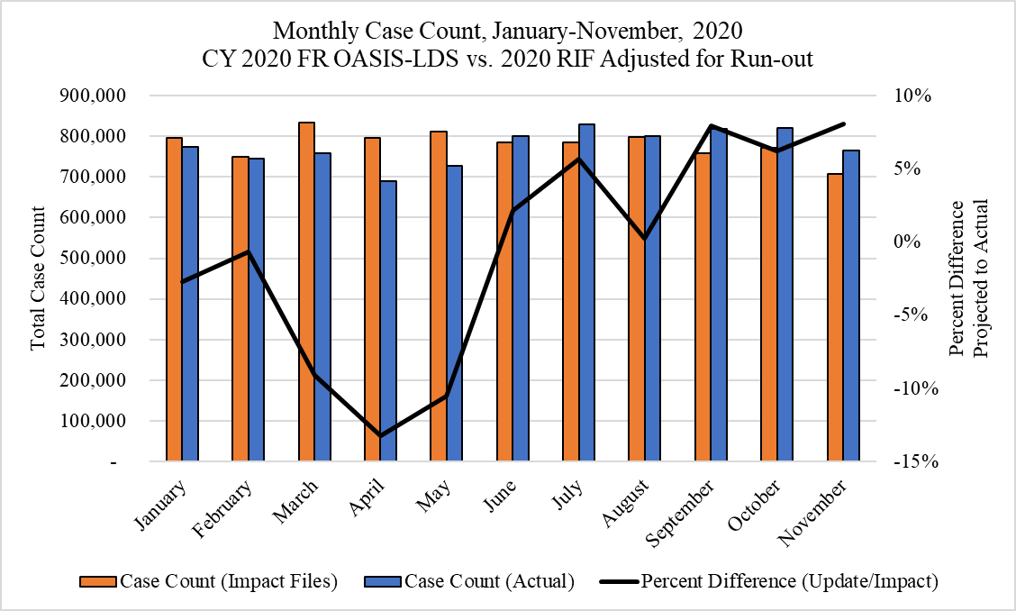
Source: Dobson | DaVanzo Analysis of HH Claims in DUAs LDS 53367 and RIF 54757
COVID-19 cases have increased for home health over the course of 2020. This includes coding for presumed or confirmed COVID-19 cases, possible exposure, negative screenings, historically used (and retired codes), and related severe symptoms (pneumonia or bronchitis due to viral or other cause). We examined inpatient, outpatient, physician office and home health claims during the home health episode and in the 30 days prior to home health admission to measure the direct service risk to home health providers in Exhibit 4.
As anticipated, we find the COVID-19 case rate among home health users – as well as reports of possible exposure and negative screening – are increasing over the period. COVID-19 patients represent an increasingly significant portion of home health cases (9% in November) with over 43% of cases having reported possible exposure and increasingly fewer patients experiencing a negative COVID-19 screening. COVID-19 home health case load in the latter half of the year reflects the ongoing PHE as well as improvements in testing, detection and inpatient treatment.

Exhibit 4: COVID-19 Case Rates, Related Symptoms, and Related Codes, Among CY2020 Home Health Users
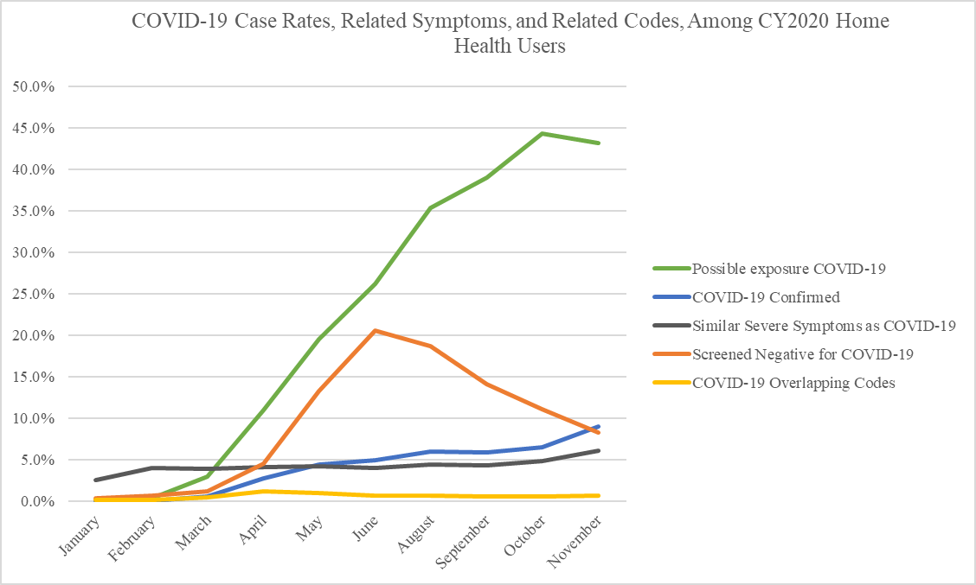
Source: Dobson | DaVanzo Analysis of HH, IP, OP, and Carrier Claims, RIF 54757

Behavioral Assumptions
The CY2020 HH PPS FR presented the 30-day payment rate in a budget-neutral manner for PDGM cases, then reduced that budget neutral base rate by -4.36% based on assumptions that providers would systemically change their visit volume and coding practices to maximize payment in the new model. The CY2021 HH PPS FR did not make adjustments to return the base rate to a budget neutral level.
CMS cited three underlying assumptions to justify the payment reduction in the CY2020 final rule:
- For one-third of LUPAs that are one to two visits away from the LUPA threshold, HHAs will provide one to two extra visits to receive a full 30-day payment.
- HHAs will change documentation and coding practices and put the highest paying diagnosis code as the principal diagnosis code. This allows a 30-day period of care to be placed into a higher-paying clinical group.
- By taking into account additional ICD-10-CM diagnosis codes listed on the HH claim (that exceed the six allowed on the OASIS), more 30-day periods of care will receive a comorbidity adjustment than periods otherwise would have received if CMS had only used the OASIS diagnosis codes for payment.
Combined, the agency indicated in the CY2020 HH PPS proposed rule that these three assumptions (which are interactive) would lead to 8.01% overrun; in the final rule, CMS reduced this to 4.36%. As described above, we find that the HH PPS during CY2020 is underpaying relative to budget neutral levels; below we address each behavioral assumption in greater detail. Ultimately, we find the behavioral assumptions have largely not come to pass:
- Observed LUPA rates greatly exceed predicted rates.
- Payment optimization of primary diagnostic coding has largely not occurred (clinical case-mix groups represent historical rather than optimized groupings).
- High comorbidity and functional need groups are bigger than expected, but this is tempered by increased relative case-mix severity with reduced volume.

LUPA Rates
During this period, actual LUPA rates were much higher than historical rates or in the rate-setting file (with or without behavioral adjustment). LUPAs are cases that do not meet the full payment visit threshold and are paid on a per-visit basis; the large portion of LUPA cases serves to reduce average case payments. We find a 15.2% LUPA rate in January-November 2020 compared to the predicted 5.3% (with behavioral assumptions) or 7.4% (historical trend without behavioral assumptions). LUPA rates were very high and increasing in the PDGM case mix groups in January and February, prior to widespread state responses to the COVID-19 PHE, as shown in Exhibit 5. This suggests that providers were immediately struggling with the new PDGM LUPA rules.
LUPA rates are consistently higher than CMS projections with or without behavioral assumptions. Though there was a major increase in LUPA rates during the initial lockdowns of the PHE, this has not recovered to expectations. That is, while the aggregate LUPA rate is slowly falling, it remains nearly three times the rate that CMS predicted in rulemaking.
Exhibit 5: Actual CY2020 LUPA Rate vs. Projected LUPA Rate
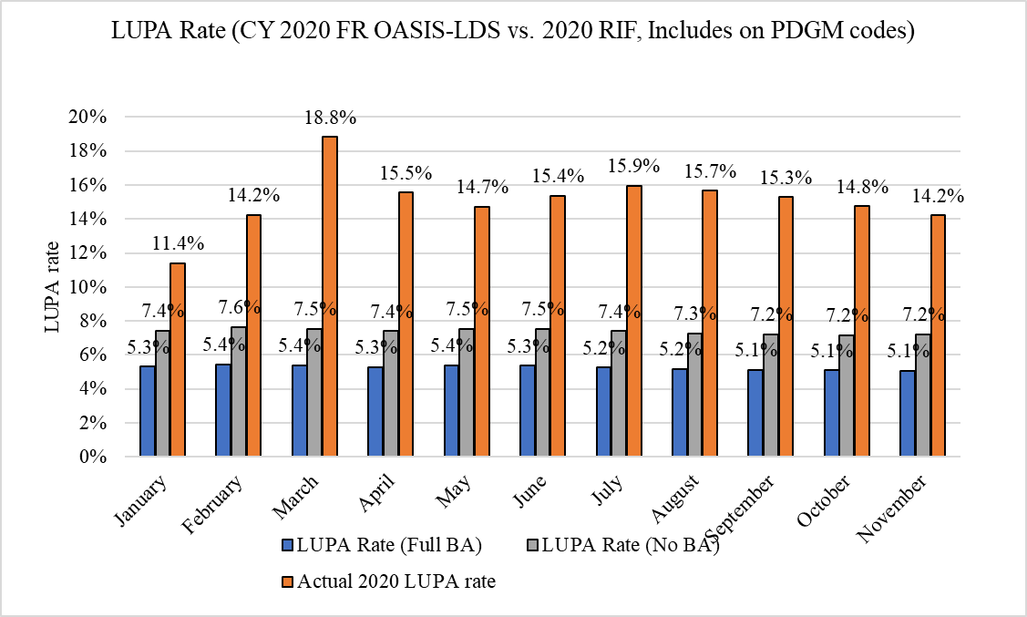
Source: Dobson | DaVanzo Analysis of HH Claims in DUAs LDS 53367 and RIF 54757
Home health providers seem to still be responding to the previous 60-day LUPA threshold and have not fully adapted to the approach where the threshold varies by 30-day case-mix. We anticipate an overall system LUPA rate remaining above 10% after providers become more familiar with the new system, because thresholds are set at the 10th percentile or higher by case-mix group. This will result in a system performs more or less as intended (10% or more cases are LUPAs), but has little to do with the assumed behavioral changes posited by CMS. Should CMS seek a lower LUPA rate, they should lower the LUPA threshold.
To further examine this issue, we grouped 30-day cases back to the 153-group HHRG system to compare the observed LUPA rate to a derived 60-day case LUPA rate (see Exhibit 6). From this analysis, we estimate the LUPA rate for 60-day cases would be about 10% under the historic system. This makes intuitive sense as the PDGM LUPA threshold was effectively set to the tenth percentile (or higher) from cases that originated in the 60-day system.
Exhibit 6: LUPA Rate (Observed and Estimated Historical HHRG) by PDGM LUPA Threshold
Visit Threshold | Observed LUPA Rate  (1st PDGM 30-day Episode matched to 60-day) | Imputed 60 Day LUPA Rate  (Historic 4-Visit Threshold) | Difference
2 | 14% | 17% | -3%
3 | 12% | 12% | 0%
4 | 13% | 8% | 6%
5 | 17% | 6% | 11%
6 | 16% | 4% | 12%
Source: Dobson | DaVanzo Analysis of HH Claims in DUAs LDS 53367 and RIF 54757

LUPA rates in PDGM are higher than the expected 10% threshold would imply, which may be partially due to the 60-to-30 day conversion applied in rate-setting. LUPA rates for PDGM cases are generally much higher than if these same cases had been grouped under the historic HHRG thresholds.

Clinical Group Coding
We find that observed case-mix groups are more similar to historical trends of primary diagnoses than to the payment-optimized groupings as projected by CMS, as shown in Exhibit 7. CMS assumed home health agencies would change their documentation and coding practices to assign the highest-paying diagnosis code as the principal code for the 30-day period of care. This has not occured. Certain groups stand out for their departure in the behavioral assumption group from historical trend – especially clinical groups MMTA-Endocrine and Neuro groups – where actual 2020 case-mix results hewed close to historical levels. This behavioral assumption would require agencies to substantially disregard international agreed coding schemas, so it is not surprising that shifts did not occur to the extent predicted in the CMS behavioral assumptions.
Exhibit 7: Observed Clinical Groups January-June 2020 Compared to Projected Clinical Groups (with and without Behavioral Adjustments)
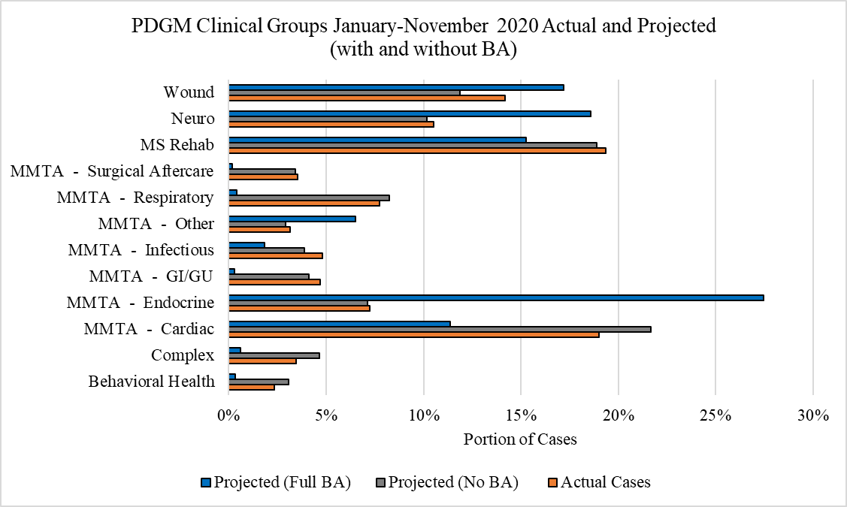
Source: Dobson | DaVanzo Analysis of HH Claims in DUAs LDS 53367 and RIF 54757

Impact on comorbidity, Functional Status, Admission Source, and Timing
Home health agencies are reporting higher comorbidity and functional group scores in 2020, even much higher than scores projected from the rate-setting files with behavioral adjustment as seen in Exhibit 8. This increases in scores could be partially explained by the change in coding behavior as anticipated by CMS, but more likely also by the relative increase in case-mix severity due the ongoing coronavirus pandemic and increasing substitution of home health for SNF care. CMS could consider examining changes in home health within the context of changing SNF volume and case-mix to address how unanticipated substitution effects across systems may be impacting expected case-mix weights.

Exhibit 8: PDGM Case-Mix Categories January-June 2020, Actual and Projected (with and without BA)
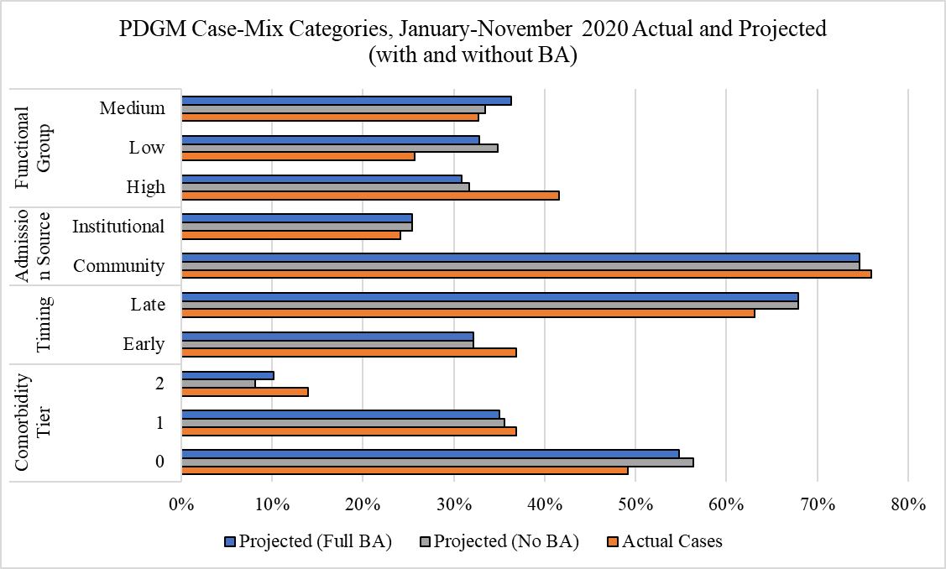
Source: Dobson | DaVanzo Analysis of HH Claims in DUAs LDS 53367 and RIF 54757
While functional status and comorbidity level are potentially sensitive to coding, admission source and episode timing are indepentend of agency reporting. Rather, changes to admission source and timing inherently represent real changes in referral sources and new patient home health starts.
Institutional admission source and Early timing case-mix groups have substantial payment advanges. We find a greater portion of cases were Institutional (+1 percentage point) or Early (+5 percentage points) compared to the behaviorally adjusted CMS impact file estimate. These changes are subtle, but impactful, and represent real changes in case-mix. These changes likely represent changing business models to adapt to PDGM and/or a changing mix of referral sources due to COVID-19. Early and institutional cases are highly incentivized in PDGM and exceedingly poor SNF pandemic performance likely created new opportunities for home health gains in these case types.

Case-Mix Severity
A key issue in both the transition to PDGM and the ongoing COVID-19 PHE is the overall severity or patient service need of home health users. We apply the aggregate case-mix weight as a proxy for case-mix severity (or patient service need) as it denotes the expected relative case resource use. As the pandemic has led to major volume changes, the apparent case-mix severity has increased. From our observations, it appears that the volume decline and LUPA rate increases affect lower severity cases. In other words, under COVID-19, patients who needed greater service use were more likely to get home health care and have a fully paid episode than otherwise.
For January-November 2020, we compare the aggregate case-mix weights across cases:
- Projected without Behavioral Assumption: 1.00
- Projected with Behavioral Assumption: 1.07
- Observed claims: 1.05
The relative increase in case-mix weights may be driven by a reduction in low-severity cases more than changes in coding. Indeed, clinical groups coding remained close to historical case-mix while overall severity increased.
This results in apparent shifts in aggregate case-mix weight across payment categories in Exhibit 9 and Exhibit 10. Case-mix severity increases appear to be largely due to the distribution of cases across the functional and episode timing groups in Exhibit 10. While all other case-mix variables show some amount of shift from historical expected case-mix weights, the functional groups are very close to the historical weights. This indicates that holding the functional status constant, case-mix severity did not change substantially – in other words, increases in apparent severity appear largely driven by the distribution of cases across functional groups.
Exhibit 9: Observed Average Clinical Group Case-Mix Weight January-June 2020 Compared to Projected Clinical Groups (with and without Behavioral Adjustments)
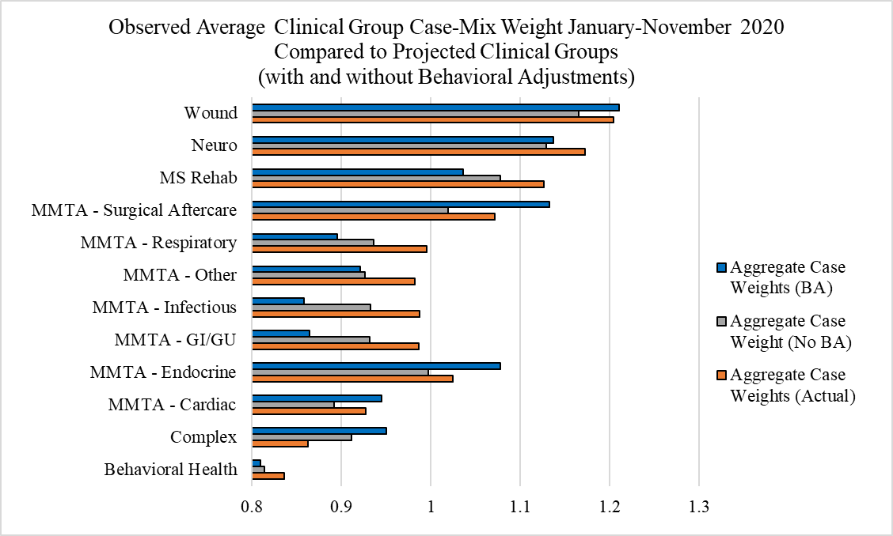
Source: Dobson | DaVanzo Analysis of HH Claims in DUAs LDS 53367 and RIF 54757
Exhibit 10: PDGM Case-Mix Categories Average Case Weights, January-June 2020, Actual and Projected (with and without BA)
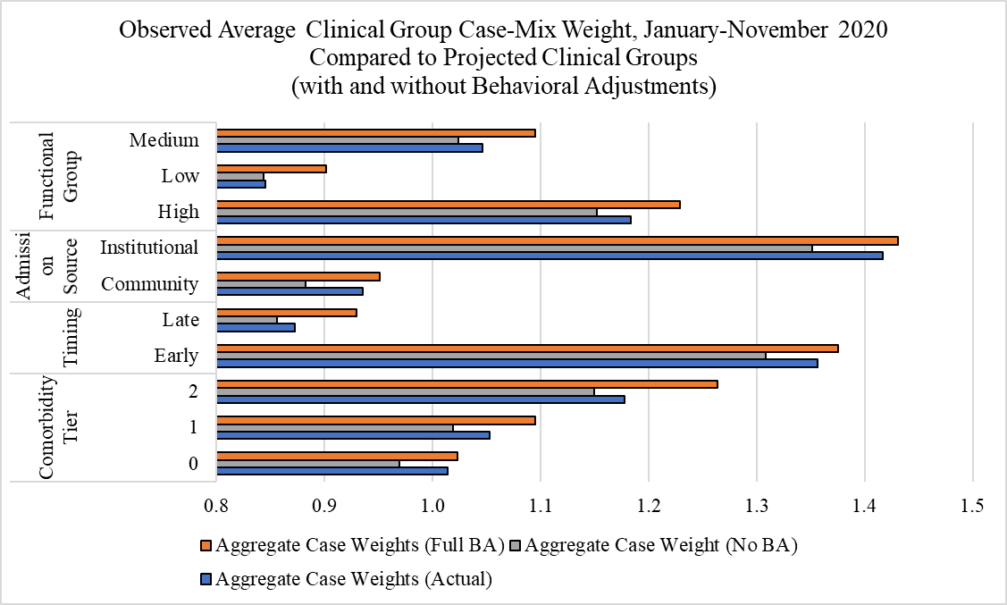
Source: Dobson | DaVanzo Analysis of HH Claims in DUAs LDS 53367 and RIF 54757
Regrouping the observed average case-mix weights back to the expected group proportions from the impact file, we find that the 1.05 case-mix is due to functional status (+0.02 contribution), timing (+0.02 contribution), comorbidity (+0.01) with admission source serving as a break (-0.01 contribution) relative to expectations.

Sequences of Care
The conversion of cases from a 60-day episode to a 30-day episode and the restructuring of payments across that sequence will likely lead to shorter sequences of care and more new home health users. So far in 2020, we find sequences have 2.4 PDGM episodes on average (or would go for about 1.2 60-day episodes). Measures of sequence length are affected by limited data (a full year or more of PDGM will ostensibly have longer sequences of care) and the COVID-19 pandemic, which may have reasonably changed how much care a patient receives. Exhibit 11 shows sequence length and LUPA rate for that position in the sequence. Through November, we find that about 42% of home health cases had a single 30-day episode (with a 13% LUPA rate).

Exhibit 11: 30-Day Sequence Length and LUPA Rate
30-Day Sequence | Portion Observed 30-Day Episodes Last Sequence | LUPA Rate
1 | 41% | 13%
2 | 22% | 19%
3 | 11% | 13%
4 | 8% | 15%
5 | 5% | 13%
6 | 4% | 15%
7 | 3% | 14%
8 | 2% | 15%
9 | 2% | 13%
10 | 1% | 14%
11 | 1% | 12%
Source: Dobson | DaVanzo Analysis of HH Claims in DUAs LDS 53367 and RIF 54757

Note that LUPA rates for each sequence are generally higher for even numbers in the sequence. This suggests that providers are still working within some concept of the 60-day system instead of compressing or spreading visits to optimize payments. We also grouped 30-day cases back to 60-day 153-group HHRG cases and did not find evidence to suggest spreading of visits for payment advantage; rather, we tended to find shorter than expected episodes, potentially indicative of practical changes resulting from the PHE to institutional referral sources as well as strong PDGM incentives which favor starting new patients rather than extending ongoing sequences.

Disentangling PDGM Implementation from COVID-19 PHE
To disentangle the effects of PDGM implementation from the COVID-19 PHE, we constructed a summary monthly database of home health case volume and several PHE-related factors at the state level. This allowed us to examine statewide average payment rates, LUPA rates and case volume while accounting for PHE-related factors such as the COVID-19 test positivity rate, inpatient census portion, and timing of state lock-down orders. We applied a fixed effects panel regression modeling approach and conducted several diagnostics and sensitivity analyses to ensure that it was the appropriate model to use.
Overall, we found that:
- Increases in state COVID-19 positivity rates (local outbreak severity proxy) are associated with a decrease in average Home Health case payment, as are increases in inpatient census.
- Increases in state COVID-19 positivity rate are associated with a decrease in HH cases; this is modulated by inpatient census (e.g., when inpatient census is high, this increases HH cases in opposition to effects of local COVID-19 outbreak severity).
- LUPA rates are not significantly impacted by the case positivity rate or state inpatient census.
These regression analyses corroborate findings from the descriptive analyses: the initial shock of the unfolding PHE and state responses had an immediate and sizable effect on health system operations in March and April, 2020. State governments and related policies have shifted subsequently and COVID-19 has had major operational effects (such as labor shortages when providers are quarantined), however this has largely been managed from Q2 onward. That is not to say real, lasting changes have not altered the provision of home health care in fundamental ways which will likely have payment model consequences.

Sources of Estimate Uncertainty
Early 2020 claims are continuing to be adjudicated. Estimates here are adjusted for initial PDGM implementation, observable claims maturity / run-out, and changing seasonality patterns. Claims are considered to be fully mature after 13 months; most recent data here has 4 months of run-out. Claims adjudication patterns in 2020 depart from prior years and seasonality patterns have changed due largely to the PHE. This adds uncertainty to estimates of case volume and payments.

Conclusion and Policy Implications
CY2020 PDGM implementation has disrupted home health operations which were then coincidentally impacted by the COVID-19 PHE. Two of the three anticipated behavioral changes that CMS used to justify prospective payment rate reductions have not occurred as of November, 2020 – overall payments and case volume are down with very high LUPA rates. This affects case-mix severity in complex ways; the PHE may be the predominant cause of the observed increase in case-mix severity rather than provider coding adjustments.
In the near-term, CMS may consider taking corrective action to increase the base rate so the HH PPS will more likely achieve budget neutrality in CY2022, as authorized by the Bipartisan Budget Act of 2018. We discuss budget neutrality in terms of average payment which is not affected by volume changes. Regardless of other mechanisms used to support agencies through COVID-19, the 2020 base payment rate is not budget neutral which affects payment adequacy in the near- and long-term. Ultimately, an unexpectedly high LUPA rate balances high case-mix weight due to changing referral sources and greater substitution for SNF care. Looking ahead, PDGM implementation and regulatory changes enacted (temporarily or permanently) to support beneficiary access and health during the COVID-19 PHE will leave a lasting imprint on the data used to rebase, set payment weights, and eventually transition to new payment systems.
The most significant shifts in PDGM case-mix are explainable by changes in referral sources and the desirability of competing institutional providers during the pandemic. First, home health referral sources are rapidly shifting. The PHE has significantly reduced the amount of elective inpatient surgeries and reduced patient reliance on emergency departments to handle exacerbations of chronic illnesses. This has shifted home health referral sources more to pre-acute patients and post-Ambulatory Surgical Center care.
Second, Skilled Nursing Facilities have become a much less desirable care setting for most patients due to exceedingly poor performance and press attention on infection control (noting that infection control is a historical problem in SNFs that has been exacerbated by the pandemic). With fewer inpatient hospitalizations and much lower patient interest in SNFs, home health has been able to substitute for certain high-frailty cases. This could very well explain the increase in observed functional score and comorbidity ratings relative to expectations. To the extent that home health is substituting more often for much more expensive and potentially harmful SNF care, it may be appropriate for CMS to consider including savings from the SNF PPS in its calculation of HH PPS budget neutrality.
The allowance of telehealth visits for home health services after the LUPA threshold is reached is potentially helpful in assuring continuous beneficiary access during the COVID-19 PHE, particularly for some monitoring and teaching services (among others) which may reasonably shift from in-person care to telehealth. However, there is no requirement to capture these services in the claims and telehealth costs are not well-reported in Medicare Cost Reports. As such, the service shift toward telehealth must be accounted for outside of the traditional rate setting and rebasing models at the risk of decreasing the payment accuracy and adequacy of the HH PPS. We raise this issue because this factor can affect analyses to incorrectly impute that there is less home health care or that home health margins have risen; instead, it is a new source of measurement error where missing data would imply that less services are provided when it is not necessarily the case.
Atypical volume and case-mix severity is occurring across all healthcare providers during the COVID-19 pandemic. Other COVID-19 PHE responses also affect payment system data in ways which may impact future payment system reform. For instance, post-acute care providers are not required to collect complete Standardized Patient Assessment Date Elements, which were designated as a key input to the timeline of payment reform proposals in the IMPACT Act of 2014.
Ultimately the COVID-19 PHE will affect future rate setting, rebasing and payment system overhauls across all Medicare payment systems. The data that are normally relied upon to conduct these activities will represent atypical behavior and be less complete than previously (e.g. telehealth and standardized patient assessment data elements (SPADES) under-reporting). The agency will need to carefully consider how it addresses and corrects for these issues. The COVID-19 PHE is changing the shape of healthcare across the country – how CMS incorporates this into rate setting (future incentives) will help determine to what extent these changes are permanently ingrained in the payment systems.

https://www.cms.gov/files/document/covid-home-health-agencies.pdf
https://www.congress.gov/115/plaws/publ123/PLAW-115publ123.pdf
Within the context of this report, we use “30-day PDGM episode” and “case” interchangeably.
Claims data here are from the August 2020 update and results adjusted with completion factors. After comparing multiple files with varying run-out, we concluded that June 2020 is adequately complete for the purposes of this report. Completion factors were 1.015, 1.020, 1.036 and 1.095 to adjust observed payments March-June (respectively), based on investigation of claims run-out.
Previously, we estimated a LUPA rate of 24.4% in 2020 using a method that benchmarked to 2019 MedPAC data, but resulted in an overestimate. After subsequent investigation, we determined that the CCW claims LUPA indicator is not functioning properly and instead attempted to replicate the pricer output LUPA determination by comparing claim visit counts to the PDGM case-mix group threshold. Additionally, we considered cases with zero visits that received a full case payment as a full case and not a LUPA as we assume the data for these cases is not complete. As such, the lower estimate here of 14.4% January-June LUPA rate may be an underestimate of the actual LUPA rate once claims are fully adjudicated.

