HCBS ARPA Funding Plan Overview & Update
Department of Health Care Policy and Financing
August 23, 2021 1:30 p.m.

Presenters:
Bonnie Silva, Director, Office of Community Living
Tracy Johnson, Medicaid Director

Agenda:
Recap: ARPA
Updates to Proposed Plan
Current Work
Implementation Timelines
Funding Mechanisms
Next Steps

Recap: ARPA
- ARPA passed by Congress on March 11, 2021
- Through ARPA, Colorado will receive $3.8 billion
- Section 9817 of ARPA includes additional funding to support HCBS access for Medicaid

Eligible Services for ARPA funds:
- 1915 HCBS Waivers
- Personal care
- Targeted case management
- Home health care
- Private duty nursing
- PACE
- Behavioral Health

Potential Fiscal Impact
- 10% enhanced match is only available for eligible services
- Approximately $500 million

North Star:
- Supercharge existing initiatives, foster innovation and advance long-term transformative systems
- Support COVID-19 response and recovery
- Demand quality and good fiscal stewardship
- Recommendation do not create a funding cliff, does not commit to future funding after 2024.

Recap: Stakeholder Engagement May 2021
- Discussed potential for these funds with advocacy, trade organizations & in going stakeholder meetings
- Hosted 7 targeted stakeholder meetings attended by nearly 800 people
- Collected feedback and recommendations through email and webinar comments
- Collected 428 survey responses

Correspondence with CMS (Partial approval)
CMS had particular questions surrounding behavioral health and acute services
- HCPF responded on August 2, 2021
- All projects meet the requirement of including services that are covered or could be covered as rehabilitative services
- None of Colorado’s proposed activities include room and board

Proposed Plan
Priorities:
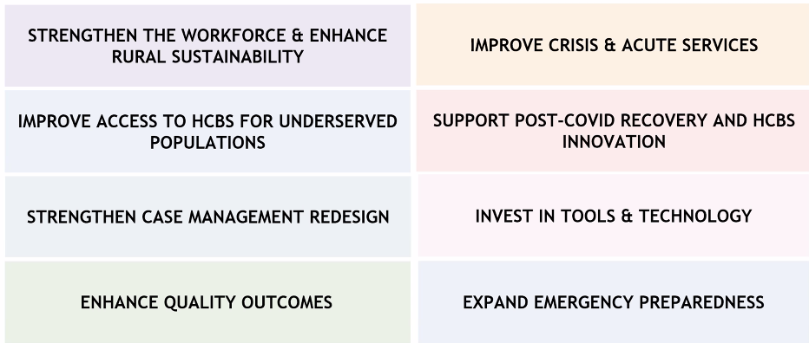

*Wage pass-throughs and reimbursement was combined into strengthen workforce and enhance rural sustainability.

72 difference projects
Waiting on full approval from CMS
JBC Submission & presentation in September

Strengthen Workforce & Rural Sustainability:
Current challenge: significant direct care workforce shortages threatening provider sustainability and access to care. Prevalent among rural providers
Anticipated outcome: Increased recruitment & retention of DCWs, an expanded rural provider network & ultimately improved access to care for members

- Implement recovery payments, wage pass-troughs & incentive payments to support the DCW. Rate increase for personal care, home maker, etc. are being proposed and will have a required pass-through. Considering making this retroactive as well
- Expand data infrastructure to better understand the current supply and demand for DCWs
- Invest in skills, advancement and awareness for DCWs. Looking at standardized training curriculum and establishing quality standards. Also considering a job search and resource hub (would have info on positions, training, job boards etc.)
- Establish training fund to support the expansion of training opportunities.
- Public awareness campaign on the value of the DCW and increase pride in these positions
- Explore opportunities for increasing compensation for the HCBS workforce (conduct research including examining benefits cliff, and increasing benefit package, practicing at the top of their license)
- Explore & reward additional opportunities to expand delegation in home health
- Identify gaps & invest in opportunities to expand provider network in rural CO

Q: Will the rate increases
A: Using the enhanced match for one-time bonus payments (sign-on, retention bonuses, etc). Making it intentional that it is not an ongoing reimbursement increase, so there is not a cliff where wages would decrease after 2024.

Incentive payments can start as soon as approval is given by CMS and JBC. Early as Fall/Winter 2021.

Improve Crisis & Acute Services:
- Make available short-term grants to mitigate placements in behavioral health institutions & support transitions from those settings back to the community
- Expand BH mobile crisis teams
- Pursuing strategies that support ATU and CSU become IMD

Improve Access to HCBS for Underserved Populations
Challenge: Many currently underserved including tribal lands, BIPOC, those with BH needs
- Conduct research and implement strategies to improve access to HCBS
- Develop disability training for providers (would be required for BH providers)
- Client facing materials that are culturally competent
- Translate member facing case management material
- Expand BH safety net, wrap around services, network building capacity

Support Post-COVID Recovery & HCBS Innovation
Challenge: Disproportionate impact on individuals residing in congregate care settings.
- Research, develop & pilot innovative residential models of care and including promoting single-occupancy
- Develop tiered rate methodology for Alternative Care Facilities
- Pilot the Community Aging in Place (CAPABLE) Program
- Expand the Supported Employment pilot
- Identifying systems of care that leverage needs of various populations (child care, college credits, etc.)
- Expand respite services and provide temp. targeted rate increase
- Develop Community First Choice (ongoing enhanced 6% match, implemented by 2025)

Strengthen Case Management Redesign
Challenge: Decades old system and CO older adult and disability populations are growing fast
- Case management capacity building to support change management with a contractor
- Identify solutions to barriers to physical and financial long term care eligibility
- Identify and implement case management best practices including rate structures and models of care management
- Develop and implement a comprehensive training for case management agencies

Invest in Tools & Technology
- Create a Long-term Home Health & PDN acuity tool (aka utilization management)
- Develop a provider specialty search tool
- Improve the member-facing provider finder tool
- Invest in upgrading and enhancing electronic health record systems for HCBS providers
- Offer member digital literacy training
- Provide funding to HCBS providers to digitally transform their care delivery
- Create pain management consultation service for those with chronic pain, mental health or SUD treatment
- Build social determinants of health information into the prescriber tool
- Expand data sharing across entities
- Improve eligibility systems to hasten application processing, provides real-time provider eligibility status insights

Enhance Quality Outcomes
- Establish metrics and develop public-facing provider scorecards
- In collaboration with CDPHE, improve and streamline provider oversight, application process, standardizing surveys across provider types, recertification every 3 years.
- Develop pay-for-performance rate methodologies for HCBS, PACE and Home Health
- Establish a PACE licensure type to ensure appropriate oversight and compliance
- Expand eConsult system to connect primary care providers with specialists
- Expand waiver quality surveys and metrics
- Expand post-release supports to members who were recently released from incarceration, on parole or probation
- Develop training on quality performance measures.

Expand Emergency Preparedness
- Support providers to develop emergency preparedness and response plans
- Assist members with disabilities and those with mental health needs to be prepared for potential emergencies by providing resources, supplies or education

Implementation Timelines:
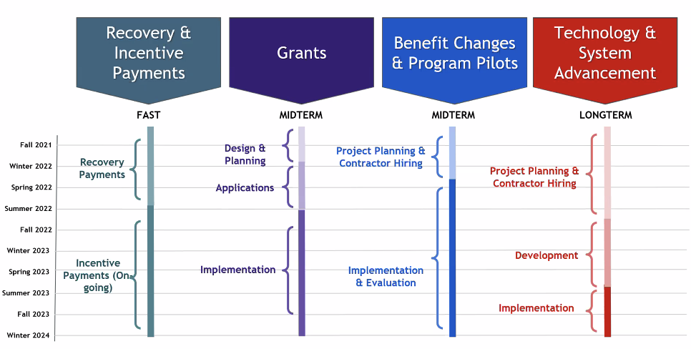

Funding and Rollout:
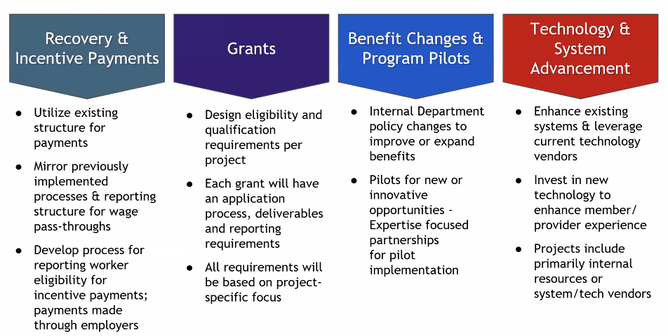

Approvals
Awaiting final CMS approval – expected any day
Seeking JBC approval
- Submit budget and narrative on September 7, 2021
- Present to the JBC on September 21, 2021
Respond to questions and requests for more information as necessary
HCPF is beginning to hire staff and put out RFPs for contractors

